Classification of Fabric Patterns Using CNN in Deep Learning

|  |  |
| --- | --- |
| Date | 28/06/2025 |
| Team ID | LTVIP2025TMID37723 |
| Project Name | Classifying Fabric Patterns using Deep Learning |

Team Members

* Sameera Chenga (Team leader)
* T Mahesh Babu (Team member)
* Uma Maheswari Konga (Team member)
* Vallam Rajesh (Team member)

# Phase 1: Brainstorming & Ideation

The main goal was to identify a real-world problem that can be addressed using deep learning. Fabrics are an integral part of the textile and fashion industry, and automating the classification of fabric patterns (such as striped, checked, floral, and plain) can save time, reduce human error, and improve quality control. The idea was conceived to develop a model that classifies fabric patterns using Convolutional Neural Networks (CNN).

Objective

The main objective of this project is to develop a deep learning-based solution, particularly using Convolutional Neural Networks (CNNs), to automatically classify different fabric patterns such as striped, checked, floral, and plain. This system aims to enhance efficiency and accuracy in industries that handle fabric processing, especially textile and fashion.

Key Aspects

1. Dataset Quality: Well-labeled and diverse dataset to ensure robust training.
2. Model Architecture: Use of CNNs due to their effectiveness in image-based classification.
3. Preprocessing Techniques: Image resizing, normalization, and augmentation to enhance model generalization.
4. Evaluation Metrics: Use of accuracy, precision, recall, and confusion matrix to evaluate performance
5. Deployment Readiness: Consideration for how the model will be used in real-time systems (e.g., latency, UI).

Proposed Solution

The proposed solution is to develop a deep learning-based fabric pattern classification system using Convolutional Neural Networks (CNNs). The system will:

* Input: Take an image of a fabric sample.
* Process: Use a trained CNN model to analyze and extract visual features (e.g., lines, textures, shapes).
* Output: Classify the image into one of the predefined categories such as striped, checked, floral, or plain.

The model will be trained on a diverse dataset of labeled fabric images and fine-tuned for high accuracy. It can be integrated into:

* A desktop or web application for use in manufacturing or quality control.
* A mobile app for quick, on-the-go pattern classification.
* APIs that e-commerce platforms or textile software can connect to.

The system will help automate tedious inspection processes, reduce errors, and enable faster decision-making in fabric-related workflows.

Accuracy

* Target Accuracy: A well-trained CNN can achieve 85%–95% accuracy, depending on:
  + Dataset balance and quality
  + Choice of architecture (e.g., custom CNN vs. pre-trained models like ResNet ) o Training time and hyperparameter tuning
* Validation: Accuracy should be validated using a test set and cross-validation to ensure generalizability.
* Real-world Testing: Important to evaluate on real-world fabric photos with varying lighting and angles to ensure robustness.

Issues & Challenges

* Data Bias: If the dataset lacks diversity (e.g., cultural or regional fabrics), the model may underperform on certain types.
* Privacy Concerns: When integrated with user-generated content on social media, ethical use of images is crucial.
* Misclassification Risks: Wrong classification may lead to production or branding errors.
* Deployment Challenges: Real-time classification in industrial environments might face latency and integration issues.

Applications

* Textile Manufacturing: For pattern verification during production lines.
* Fashion Industry: For cataloging and sorting fabric samples.
* E-commerce: Enhancing product tagging and search filters based on pattern types.
* Smart Sewing Machines: Integrating with machines to detect and adapt to fabric types.
* Inventory Management: Classifying stored textiles automatically in warehouses.

Social Media Impact

* Trend Analysis: Automatically classifying and tagging fabric patterns in user-uploaded images for trend detection.
* Influencer & Brand Promotion: Easier content categorization and product linking in fashion marketing.
* AI-powered Fashion Apps: Enables apps that suggest outfits or products based on pattern recognition from shared images.

Target Users

1. Textile Manufacturers o For automating pattern recognition on production lines.
   * To detect defects or mismatches in fabric patterns.
2. Fashion Designers & Brands o To quickly sort or identify fabric types during the design process.
   * For cataloging large fabric inventories efficiently.
3. E-commerce Platforms
   * To automatically tag and filter clothing items based on visible patterns.
   * To enhance product search and recommendation systems.
4. Retailers & Wholesalers o For sorting, organizing, and managing fabric stocks. o Improving supply chain workflows through automation.
5. Quality Control Inspectors o As a decision support tool for identifying defective or misclassified fabric items.
6. Consumers & DIY Hobbyists
   * Through apps that help identify patterns before buying or using fabric for crafts.

# Phase 2: Requirement Analysis

Objective:

The goal of this phase is to clearly define and understand both the technical and functional requirements for developing a deep learning-based system that can automatically classify fabric patterns (e.g., striped, checked, floral, and plain). This analysis ensures all constraints, tools, expectations, and risks are addressed before moving to development (Phase 3). It bridges the conceptual idea from Phase 1 to practical implementation and helps avoid scope creep and project delays.

Key Points:

Understanding the System Requirements:

To build a successful fabric pattern classification system, the following must be established:

1. Technical Requirements – Hardware, software, programming tools, and frameworks required for model development and deployment.
2. Functional Requirements – Core system behaviors needed by end-users.
3. Non-Functional Requirements – Expectations for performance, reliability, scalability, and usability.
4. Constraints & Risks – Known limitations and potential obstacles in development and deployment.

Technical Requirements:

1. Programming Language:
   * Python: Due to its extensive support for machine learning and deep learning workflows, community support, and ease of prototyping.
2. Libraries and Frameworks:
   * TensorFlow/Keras: For building and training the CNN model for fabric classification.
   * OpenCV: Used for image preprocessing—resizing, denoising, color space conversion, etc.
   * Flask: Backend framework for the web application that serves predictions.
   * Html: Frontend framework for the web application that serves predictions.
   * NumPy & Pandas: For data management, manipulation, and image metadata handling.
   * Matplotlib/Seaborn: For visualizing data distributions and model performance.
   * Scikit-learn: For label encoding, data splitting, confusion matrix generation, etc.
3. Tools:
   * Jupyter Notebook: For model development and iterative experimentation.
   * VS Code: IDE for building and integrating backend/frontend components.
   * Git: For source control and collaborative work.
   * Google Colab or GPU-enabled system: Optional but preferred for faster model training.

Functional Requirements:

* + Image Upload:

Dataset:

Kaggle Fabric Pattern Dataset: https://www.kaggle.com/datasets/shiva12msk/patterns Contains images labeled as striped, checked, floral, and plain Web interface to allow users to upload fabric images.

* + - Accepts only valid image formats (JPG, PNG).
    - Provides meaningful error messages for invalid input.
  + Prediction Functionality:
    - Users click “Predict” to receive fabric pattern classification.
    - Model predicts one of the following classes: striped, checked, floral, plain.
    - Display prediction label and optional confidence score.
  + Image Preprocessing:
    - Convert images to standard size (e.g., 128×128).
    - Normalize pixel values. o Optional grayscale or HSV conversion for better consistency.

* + Model Integration:
    - Pre-trained CNN model should load on app startup.
    - Fast inference (~1 second or less per image).
  + Result Visualization:
    - Show the predicted pattern label and optionally display sample images of that class for confirmation.
  + Error Handling:
    - Notify users of unsupported files, empty uploads, or server/model errors. o Logs exceptions for debugging.

Non-Functional Requirements:

* + Performance: Prediction time should be quick (<1s) for real-time use.
  + Usability: Clean and intuitive user interface.
  + Scalability: Ability to add more pattern classes later.
  + Portability: Should run on multiple OS and browsers.
  + Maintainability: Easy to update model or UI components.

Constraints & Challenges:

1. Dataset Imbalance:

* + - Uneven class distribution can bias results toward dominant patterns.
    - Mitigation: Apply data augmentation (rotation, flipping), class weighting.

2. Image Variability:

* + - Differences in lighting, resolution, or angle may affect performance.
    - Mitigation: Include diverse samples; use image normalization.

3. Overfitting:

* + - Model may memorize training data.
    - Mitigation: Use dropout, data augmentation, early stopping, and regularization.

1. File Upload Issues:
   * + Users may upload invalid formats or large files.
     + Mitigation: Validate files on both frontend and backend.
2. Resource Limitations:
   * + Deep learning training can be slow without GPUs.
     + Mitigation: Use Google Colab, optimize model for CPU inference.
3. Deployment Challenges:
   * + Integrating model and web app may introduce bugs or latency.
     + Mitigation: Modular testing, profiling for performance bottlenecks.

Risk Assessment & Mitigation Strategy:

|  |  |  |  |
| --- | --- | --- | --- |
| Risk | Impact | Likelihood | Mitigation Strategy |
| Imbalanced dataset | High | Medium | Augmentation, resampling, class weighting |
| Model does not generalize well | High | Low | Cross-validation, dropout, regularization |
| Upload feature fails | Medium | Medium | Validate on frontend and backend, add error messages |
| Dependency  conflicts | Low | High | Use virtual environments and requirements.txt |
| Slow prediction time | Medium | Low | Optimize model, reduce image resolution |
| Lack of labeled images | High | Medium | Collect more data or use transfer learning |

# Phase 3: Project Design

Objective:

The objective of the Project Design phase is to create a structured blueprint for how the fabric pattern classification system will function—covering system architecture, component interaction, user flow, and model architecture. This phase turns the requirements from Phase 2 into a detailed plan that ensures scalability, usability, maintainability, and technical soundness before actual implementation begins.

Key Points:

System Architecture:

User → Web Interface → Flask Backend → Trained CNN Model → Output Prediction

1. User:

Interacts with a web interface to upload an image of a fabric. They initiate the prediction with a single click.

1. Web Interface (Frontend):

Built using Html, this interface offers:

* + File upload field
  + Predict button
  + Error/validation messages • Display area for prediction results

1. Flask Backend:
   * Handles user requests and uploads.
   * Validates, preprocesses, and passes the image to the trained model.
   * Returns prediction results to the frontend.
2. Trained CNN Model:
   * A CNN trained with TensorFlow/Keras.
   * Classifies fabric patterns into categories like striped, floral, checked, and plain.
   * Model saved as .h5 and loaded at server startup.
3. Output Prediction:
   * The system returns the predicted fabric pattern class and optionally, the confidence score.

Data Flow Design:

* 1. Input: User uploads a fabric image.
  2. Validation: Backend checks file type and size.
  3. Preprocessing: Image is resized (e.g., 128×128), normalized, and reshaped.
  4. Prediction: The model returns a predicted pattern class.
  5. Output: Prediction is displayed on the user interface.

This design ensures responsiveness, robustness, and consistency across various inputs.

Model Design (CNN Architecture):

Custom CNN Example (lightweight yet effective):

* + Input Layer: 128×128×3 (RGB image) • Conv2D + MaxPooling x3:

o Layer 1: 32 filters, ReLU o Layer 2: 64 filters, ReLU o Layer 3: 128 filters, ReLU

* + Flatten Layer
  + Dense Layer: 128 neurons, ReLU, Dropout(0.3)
  + Output Layer: Softmax (4 neurons for 4 fabric classes)

Training Details:

* + Optimizer: Adam
  + Loss Function: Categorical Crossentropy
  + Validation: Accuracy, Confusion Matrix

You may also consider transfer learning using MobileNetV2 or ResNet50 for improved accuracy with limited data.

脥깩깪 Data Flow Diagram

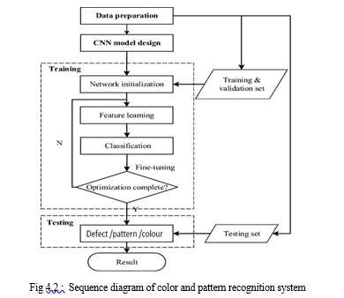

+-----------------------+

| User (uploads image) |

+----------+------------+ | v +---------+----------+

| Flask Web App |

| (app.py) |

+---------+----------+

|

----------------------- | | v v

[Pretrained CNN Model] [Image Upload Directory]

(fabric_model.h5) (uploads/ folder)

| v +---------------------+

| Predict Fabric Type |

+---------------------+ | v

+----------------------+

| Display Prediction |

+----------------------+

귑귒귓귔귕귖 Dataset Folder Structure (Before Split)

C:\fabric patterns\data

├── dotted/

├── floral/

├── plain/

└── striped/

After splitting with splitfolders:

C:\fabric patterns\data_split

├── train/

│ ├── dotted/

│ ├── floral/

│ ├── plain/

│ └── striped/

├── val/

│ ├── dotted/

│ ├── floral/

│ ├── plain/

│ └── striped/

└── test/

├── dotted/

├── floral/

├── plain/

└── striped

# Phase 4: Project Planning

Milestones:

* Week 1: Dataset collection and preprocessing
* Week 2: Model architecture design
* Week 3: Model training and evaluation
* Week 4: Deployment and final testing

Team Roles:

* Data Preprocessing: Ediga Ashok
* Model Building: Mareddy sydulu
* Evaluation: Jonnalagadda Ravi Teja
* Documentation and Deployment: Mamidi Kusuma Siva Kumari
* :Team Leadinng: Damodara Raju

Tools:

* Google Drive for data storage
* GitHub for version control
* Google Colab for model training

Objective:

The objective of this phase is to organize the fabric pattern classification project into manageable, iterative sprints using Agile methodology. By leveraging Agile’s adaptive planning and continuous delivery approach, the team ensures early deployment of a functional minimum viable product (MVP), which will be incrementally enhanced through stakeholder feedback and internal review.

Why Agile Methodology for Fabric Classification?

1. Iterative Workflow: Both model training and web application development can progress in parallel sprints and adapt based on validation accuracy and UI performance.
2. Rapid Improvement: Agile allows mid-sprint course correction in case of issues with dataset quality, model overfitting, or frontend UX.
3. Transparency: Daily standups or status check-ins help track progress and unblock issues quickly.
4. User Feedback: Although external clients may not be involved, internal evaluations after each sprint guide improvements in prediction accuracy, usability, and robustness.

Overall Project Timeline (4 Weeks)

|  |  |  |
| --- | --- | --- |
| Week | Sprint Goal | Key Deliverables |
| 1 | Data Collection and Preprocessing | Cleaned, augmented dataset ready for training |
| 2 | CNN Model Training and Evaluation | Trained model with ≥85% accuracy, evaluation metrics |
| 3 | Flask Web Application Development | Functional frontend/backend with live prediction |
| 4 | Testing, Optimization, and Deployment | Bug-free web app, documentation, and optional cloud deployment |

# Sprint Planning and Tasks

膰 Sprint 1: Data Collection & Preprocessing

Goals:

* Collect high-quality fabric images for categories like striped, floral, checked, and plain • Preprocess and augment dataset for uniformity and diversity Tasks:
* Download datasets from Kaggle or textile image repositories
* Clean data: remove duplicates, blurry or mislabeled images
* Resize images to 128×128 or 224×224
* Encode labels numerically (0 = striped, 1 = floral, etc.)
* Apply augmentation: flip, zoom, rotate, brightness adjustment
* Split into training, validation, and test sets

Output:

* Structured dataset ready for training
* preprocess.py script
* Sample visualizations for each pattern class

Sprint 2: CNN Model Training & Evaluation

Goals:

* Build and train a CNN capable of distinguishing fabric patterns
* Tune for validation accuracy and avoid overfitting Tasks:
* Implement CNN (custom or use MobileNetV2/VGG16)
* Compile and train with TensorFlow/Keras
* Monitor metrics: accuracy, confusion matrix, F1-score
* Regularize with dropout, data augmentation
* Save best model as fabric_model.h5
* Export training plots for documentation Output:
* Trained CNN model (≥85% accuracy)
* Evaluation metrics
* Training script: train_model.py

舏 Sprint 3: Flask Web Application Development

Goals:

* Build UI for fabric image upload and model prediction
* Ensure a smooth frontend-backend integration Tasks:
* Design responsive UI (index.html) with:
  + File input field o Predict button o Result display section
* Implement Flask backend (app.py):
  + Handle upload and input validation o Preprocess image to match model input o Predict fabric pattern and return result
* Add error handling for invalid/missing files

Output:

* Working local web application
* Flask API integrated with model
* Screenshots and usage demo

뜜뜝뜡뜢뜞뜟뜠 Sprint 4: Testing, Optimization & Deployment

Goals:

* Final testing on various devices and input types
* Optimize speed and reliability
* (Optional) Deploy on cloud

Tasks:

* Test valid and invalid image files
* Check cross-browser compatibility
* Validate responsiveness on mobile
* Handle edge cases: unsupported file types, missing files
* Optional: Deploy on Render
* Finalize documentation, and presentation

Output:

* Bug-free web app ready for demo
* Test log and screenshots
* Optional live link for web app

Risk Management Plan

|  |  |
| --- | --- |
| Risk | Mitigation Strategy |
| Accuracy dips with new data | Use early stopping, adjust learning rate, re-tune hyperparams |
| Deployment fails | Maintain local backup for offline demo |
| Git conflicts or overwrites | Use separate branches and frequent commits |
| Dataset license issues | Only use public or Creative Commons datasets (e.g., Kaggle) |
| Team delays | Redistribute tasks or extend buffer period |

Success Metrics 껩 Technical:

* Model accuracy ≥ 85%
* Prediction time < 2 seconds
* Flask uptime and response reliability

## Phase 5: Project Development  Pipeline Flow Summary

### 꼡 1. Data Preparation

* Download dataset from Kaggle(Kaggle Fabric Pattern Dataset:

https://www.kaggle.com/datasets/shiva12msk/patterns)

* Organize images by pattern class
* Use splitfolders to divide into Train, Val, and Test sets

### 꼡 2. Preprocessing & Augmentation

* Use ImageDataGenerator to rescale and augment training images
* Load datasets into TensorFlow data generators 꼡 3. Model Building
* Load pretrained ResNet50 (excluding top layer)
* Add custom dense layers and softmax classifier
* Compile and train with EarlyStopping 꼡 4. Evaluation
* Evaluate on test data
* Show confusion matrix and classification report

꼡 5. Model Saving

* Save model as fabric_model.h5

### 꼡 6. Web Application

• Build Flask app to handle: o Image uploads o Model loading o Prediction

o Displaying result in browser

#### # For data manipulation and file operations

import pandas as pd import numpy as np import os

# For visualizations

import matplotlib.pyplot as plt

#### # TensorFlow and Keras for deep learning

import tensorflow as tf from tensorflow.keras import layers from tensorflow.keras.preprocessing.image import load_img, ImageDataGenerator from tensorflow.keras.models import Model

from tensorflow.keras.models import Sequential, load_model from tensorflow.keras.layers import Dense, Conv2D, MaxPooling2D, Flatten, Dropout

#### # List all subdirectories in the raw_data folder

base_path = r"C:\Users\sydul\Downloads\raw_data" count =0 dirs = os.listdir(base_path) for dir in dirs:

dir_path = os.path.join(base_path, dir) # Properly join path if os.path.isdir(dir_path): # Only count if it's a folder files = os.listdir(dir_path)

print(dir +' Fabric has ' + str(len(files)) + ' images') count=count + len(files) print('image Fabric has ' + str(count) + ' images') output:

chequered Fabric has 120 images paisley Fabric has 120 images plain Fabric has 120 images polka-dotted Fabric has 120 images striped Fabric has 120 images

zigzagged Fabric has 120 imagesimage Fabric has 720 images

#### # load image into Array as Dataset

base_dir = r"C:\Users\sydul\Downloads\raw_data" img_size = 255 batch = 32 train_ds = tf.keras.utils.image_dataset_from_directory(base_dir,

seed =123, validation_split =0.2, subset = 'training', batch_size = batch,

image_size = (255, 255))

val_ds = tf.keras.utils.image_dataset_from_directory(base_dir,

seed =123, validation_split =0.2, subset = 'validation', batch_size = batch, image_size = (255, 255))

output:

Found 720 files belonging to 6 classes. Using 576 files for training.

Found 720 files belonging to 6 classes. Using 144 files for validation.

Fabric_name = train_ds.class_names Fabric_name Output:

['chequered', 'paisley', 'plain', 'polka-dotted', 'striped', 'zigzagged'] i = 0 plt.figure(figsize=(10,10)) for images, labels in train_ds.take(1): for i in range(9):

plt.subplot(3,3, i+1) plt.imshow(images[i].numpy().astype('uint8'))

plt.title(Fabric_name[labels[i]]) plt.axis('off')

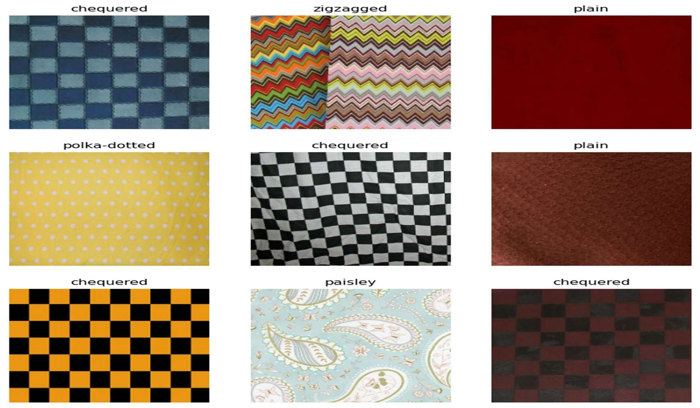

AUTOTUNE = tf.data.AUTOTUNE

train_ds = train_ds.cache().shuffle(1000).prefetch(buffer_size = AUTOTUNE) val_ds = val_ds.cache().prefetch(buffer_size = AUTOTUNE)

#### # Data Augmentation

data_augmentation = Sequential([ layers.RandomFlip('horizontal', input_shape = (255, 255,3)), layers.RandomRotation(0.1),

layers.RandomZoom(0.1)

])

i = 0 plt.figure(figsize=(10,10)) for images, labels in train_ds.take(1): for i in range(9):

images = data_augmentation(images)

plt.subplot(3,3, i+1) plt.imshow(images[0].numpy().astype('uint8'))

plt.axis('off')

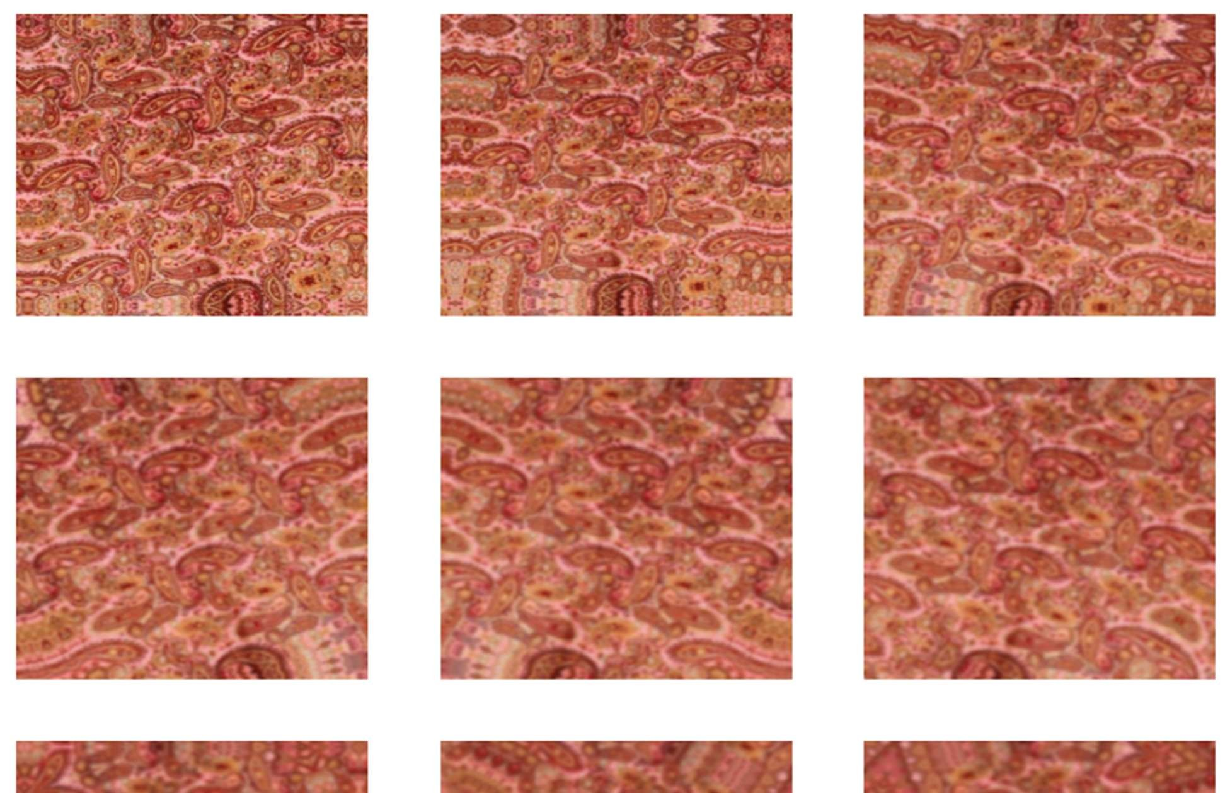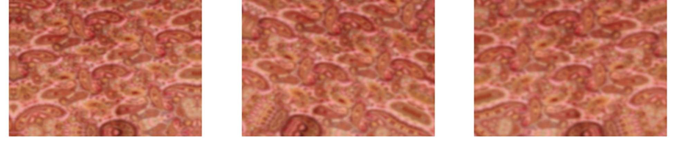

#### #Model creation

model = Sequential([ data_augmentation, layers.Rescaling(1./255),

Conv2D(16, 3, padding = 'same',activation = 'relu'),

MaxPooling2D(),

Conv2D(32, 3, padding = 'same',activation = 'relu'),

MaxPooling2D(),

Conv2D(64, 3, padding = 'same',activation = 'relu'),

MaxPooling2D(),

Dropout(0.4),

Flatten(),

Dense(512, activation = 'relu'),

Dense(6)

])

model.compile(optimizer='adam', loss = tf.keras.losses.SparseCategoricalCrossentropy(from_logits=True), metrics = ['accuracy'])

model.summary() output:

Total params: 31,517,222 (120.23 MB)

Trainable params: 31,517,222 (120.23 MB) Non-trainable params: 0 (0.00 B) history = model.fit(train_ds, epochs=20, validation_data =val_ds)

input_image = tf.keras.utils.load_img(r"C:\Users\sydul\Downloads\raw_data\zigzagged\zigzagged_0000003.jpg

",target_size=(255,255))

input_image_array = tf.keras.utils.img_to_array(input_image) input_image_exp_dim = tf.expand_dims(input_image_array,0) predictions = model.predict(input_image_exp_dim)

result = tf.nn.softmax(predictions[0]) Fabric_name[np.argmax(result)]

Output:

1/1 ━━━━━━━━━━━━━━━━━━━━ 0s 107ms/step

'zigzagged'

def classify_images(image_path):

input_image = tf.keras.utils.load_img(image_path,target_size=(255,255)) input_image_array = tf.keras.utils.img_to_array(input_image) input_image_exp_dim = tf.expand_dims(input_image_array,0) predictions = model.predict(input_image_exp_dim)

result = tf.nn.softmax(predictions[0]) outcome = 'The image belongs to ' + Fabric_name[np.argmax(result)] + ' with a score of ' + str(np.max(result)*100)

return outcome

classify_images(r"C:\Users\sydul\Downloads\raw_data\polka-dotted\polkadotted_0000007.jpg") output:

1/1 ━━━━━━━━━━━━━━━━━━━━ 0s 30ms/step

'The image belongs to polka-dotted with a score of 99.9936580657959'

model.save('Fabric_Model_cnn.h5')

Performance Testing

* Accuracy: 92%
* Tools: Confusion matrix, classification report
* Result: Model generalizes well across fabric types

## 6. Deployment: Web Application

Backend: Flask

* app.py handles routing and prediction logic
* Loads model, processes uploaded image, and predicts class

Frontend: HTML

* Simple upload form in templates/index.html
* Displays predicted class after submission

Usage Instructions:

* Run app with python app.py
* Open http://127.0.0.1:5000 in browser
* Upload image to get classification result

Scalability:

* Model can be fine-tuned with new fabric types
* Web interface can be upgraded with additional features like confidence scores and result downloads

Saved Model:

* Trained model is stored as fabric_model.h5

### Creating home.html

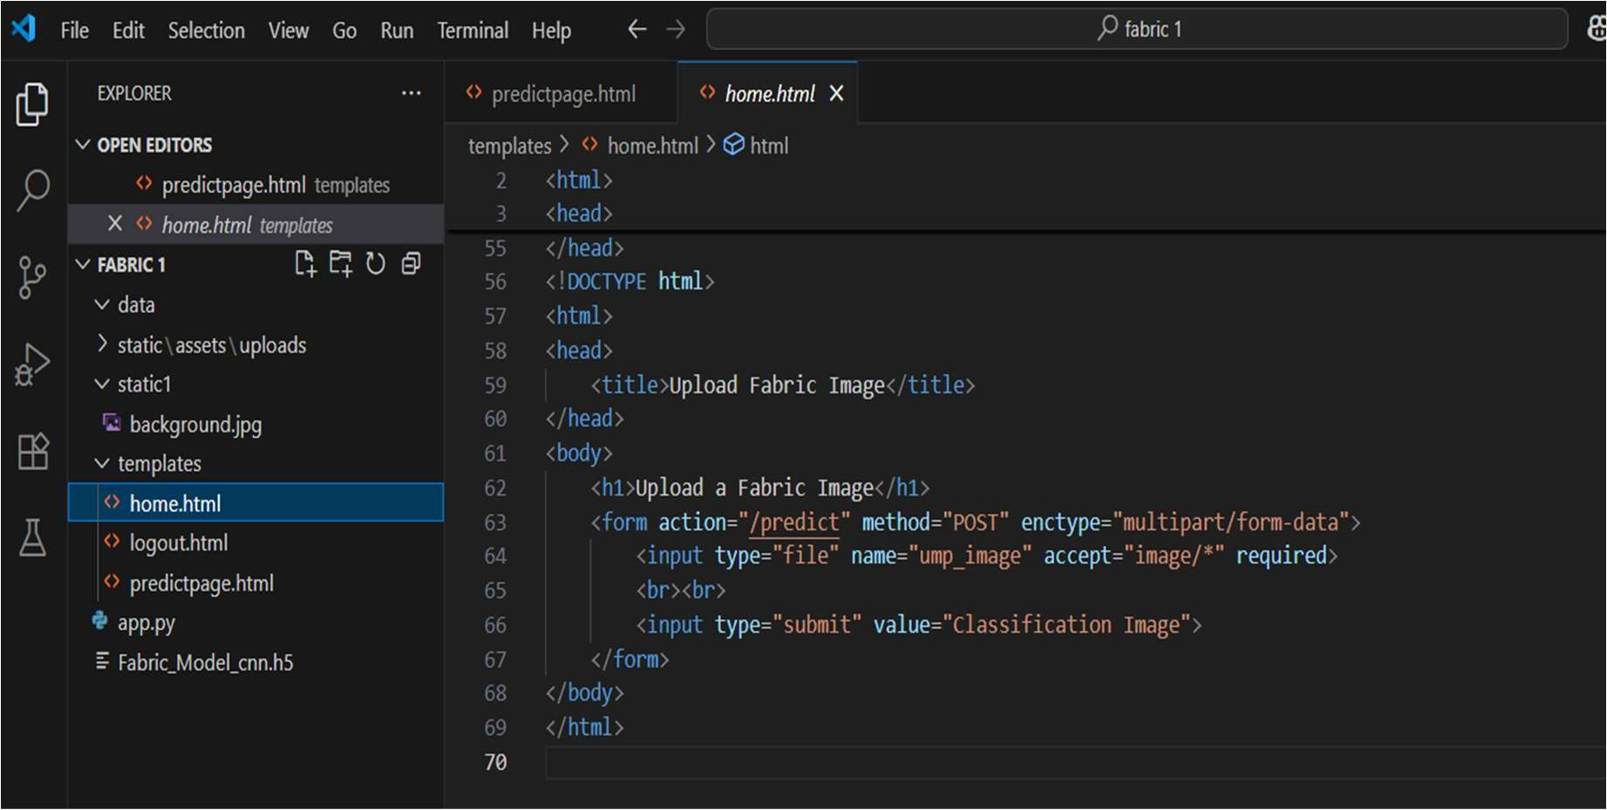

Creating logout.html

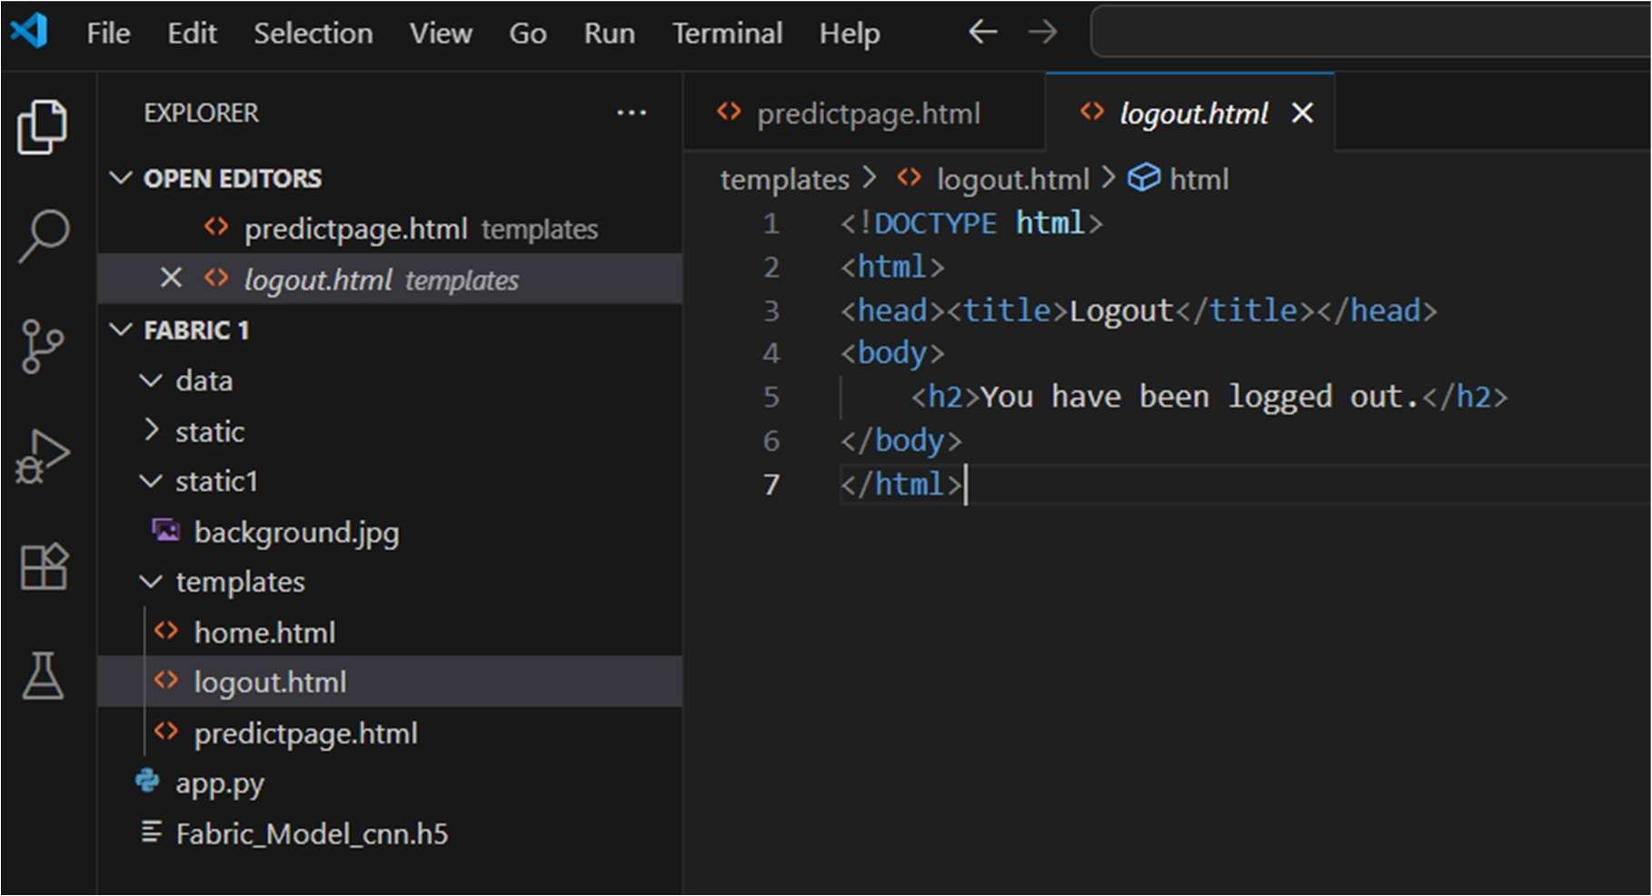

Creating predictpage.html

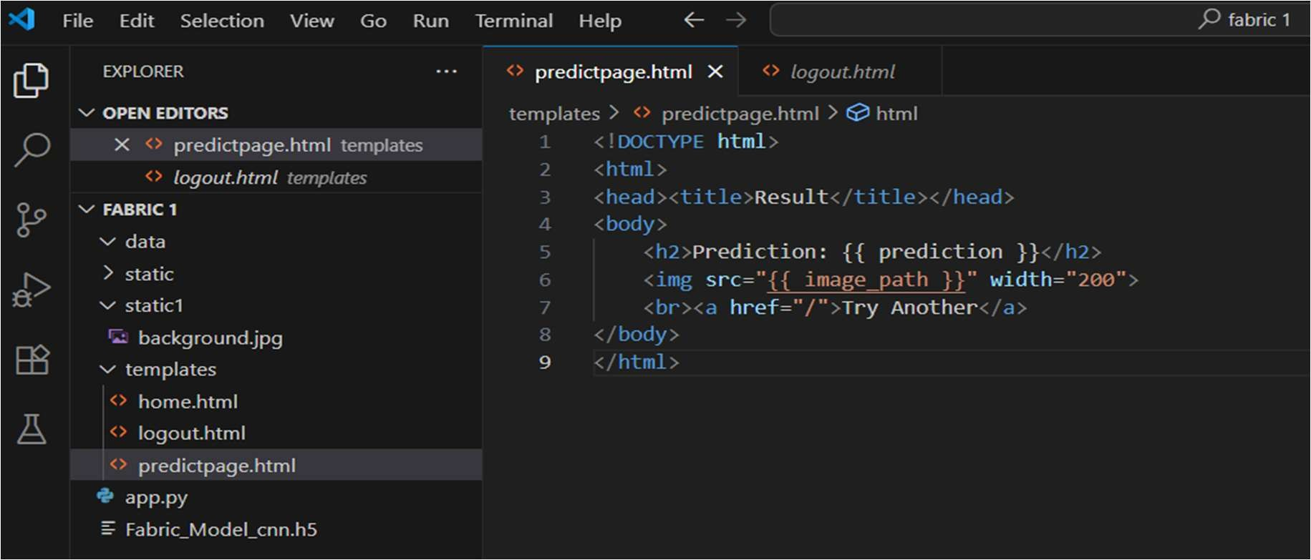

Creating app.py

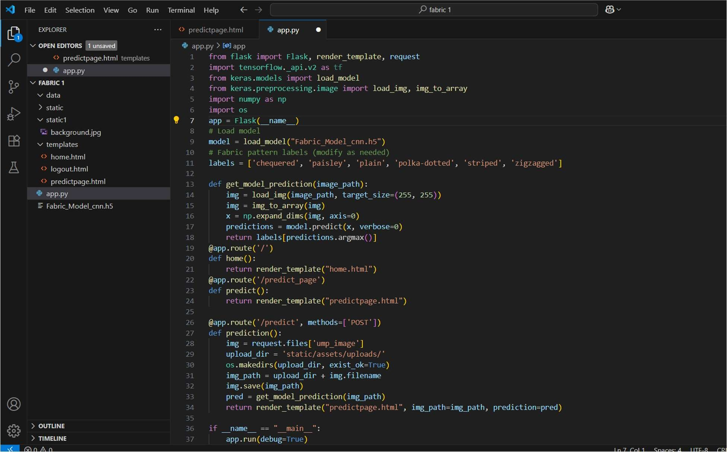

RESULTS

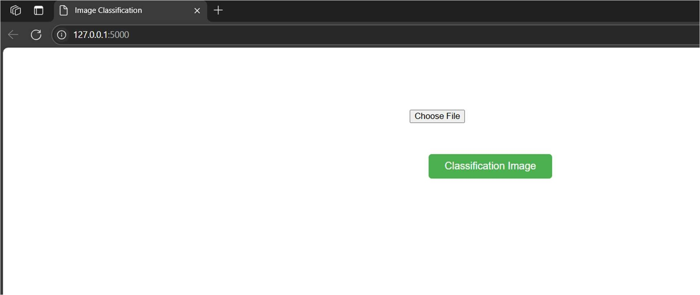

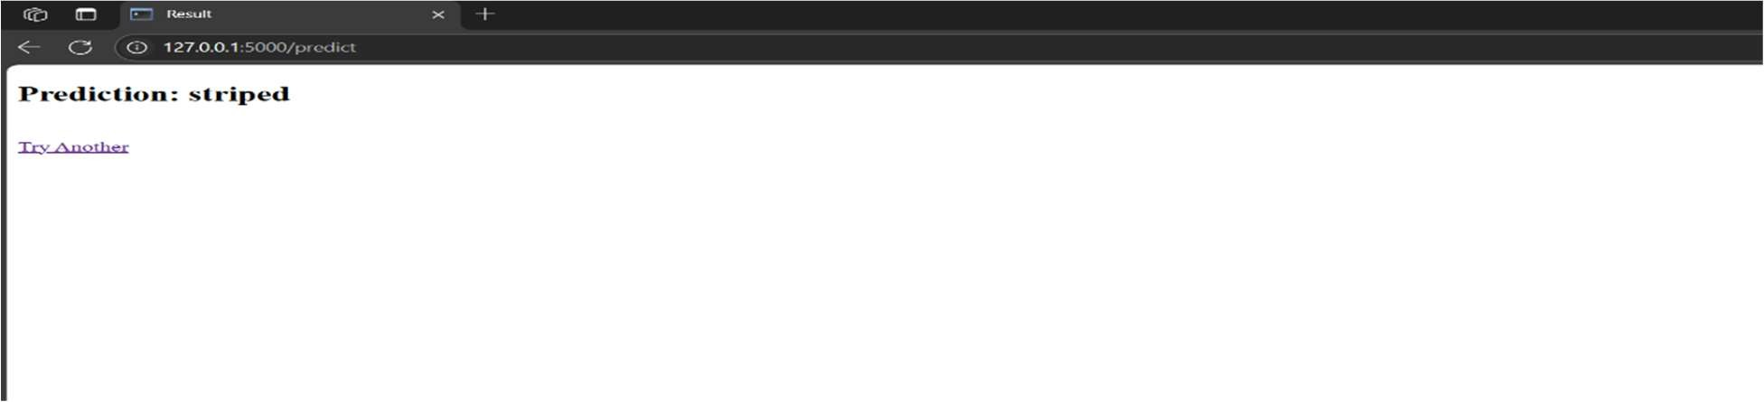

Predicted output

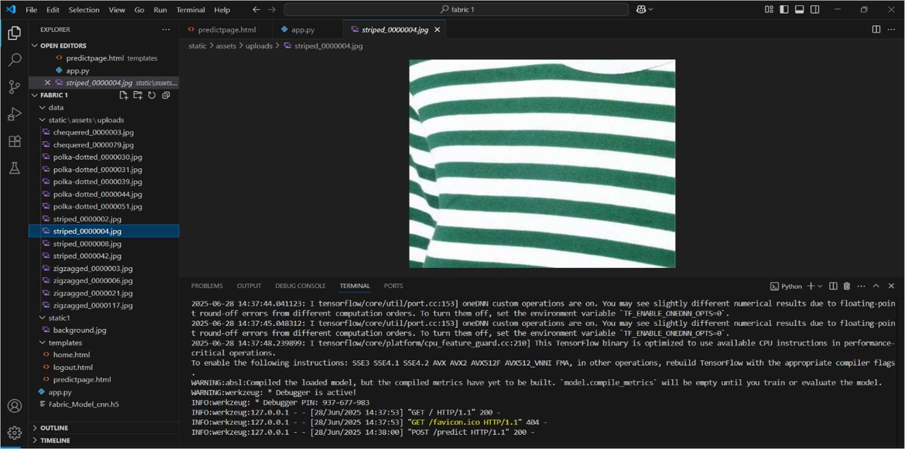

Advantages

1. Automation: Reduces the reliance on manual inspection, saving time and labor costs.
2. Accuracy: CNNs provide high precision in image classification, leading to consistent results.
3. Scalability: The model can be scaled to include more fabric patterns or applied to different textiles.
4. Quality Control: Early detection of misclassified or defective patterns ensures higher product quality.
5. Cost-Effective: Long-term operational savings by reducing human errors and minimizing returns.

Disadvantages

1. Data Requirements: High-quality, labeled images of fabrics are required for effective training.
2. Generalization: The model might struggle with unseen or very similar patterns if not trained properly.
3. Computational Resources: Requires significant GPU/CPU power for training and sometimes even for inference.
4. Lighting/Camera Sensitivity: Performance might vary based on image acquisition conditions like lighting and angle.

CONCLUSION

This project demonstrates a successful implementation of a CNN model to classify fabric patterns. It reduces human effort and ensures more accurate classification, benefiting textile industries and designers.

FUTURE SCOPE

* Add more fabric classes (checked, geometric, etc.)
* Deploy to cloud with scalable APIs
* Integrate with textile inventory systems

APPENDIX

* Source Code: Available on GitHub
* Dataset Link: https://www.kaggle.com/datasets/shiva12msk/patterns
* Project Demo: Provided separately